**Fintech Domains**

**Payments and Remittances**

**What it does:**

Send money to anyone across the country/world.

**Competitive landscape:**

Crypto, Venmo, Cashapp, Remitly

**Main factors for change:**

* Ease/speed of transfers is improving
* Able to send money across borders without intervention/3rd parties

**Technologies used:**

Crypto/blockchain/web3, web/mobile apps

**Past/Present/Future:**

Western Union -> Paypal -> Venmo/CashApp -> Crypto

**_______________________________________**

**Robo Advisors and Personal Finance**

**What it does:**

Allows you to implement sophisticated investing strategies through automated investment advisors

**Competitive landscape:**

Wealthfront, Betterment, Personal Capital, E*TRADE Core Portfolios

**Main factors for change:**

* Lower fees/barriers to entry
* Lower account minimums

**Technologies used:**

Machine learning, web/mobile apps

**Past/Present/Future:**

Stock brokers -> E*trade -> Wealthfront, Betterment, Personal Capital

**RegTech**

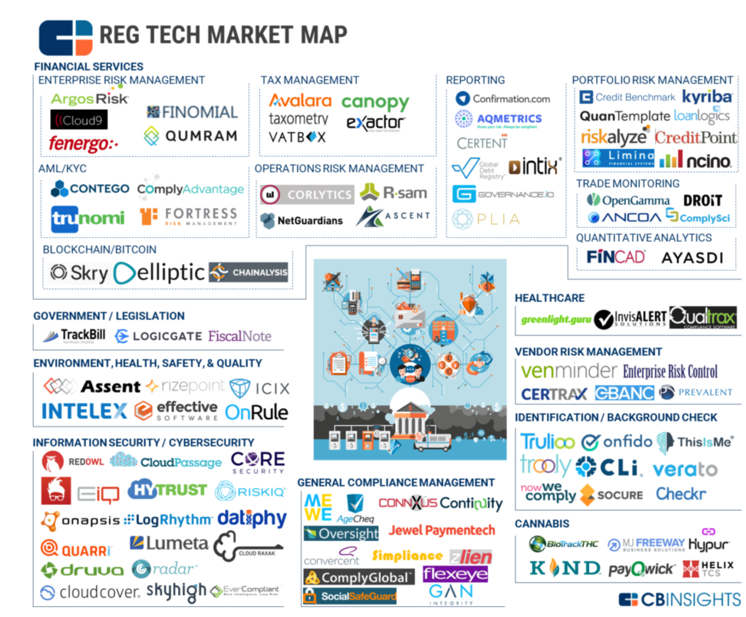

**_______________________________________**

**Digital Banking**

**_______________________________________**

**InsurTech - an extension of Regtech**

Companies: Next Insurance, zipari, metromile, corvus insurance

Opportunities: Lower Costs by less wrong projections, wrong payouts, lower fraud and illusion.

**_______________________________________**

**Alternative Finance**

**Competitive landscape:**

Seedinvest, Kickstarter, Go Fund Me, Patreon, VC Firms

**What it does:**

Non-Bank avenues of sourcing capital usually for small/independent business

**Past/Present/Future:**

Past was all VC Firms or finding an independent investor.

Research each domain and use your findings to answer the following questions:

What does the particular FinTech domain do? What is it's purpose?

What is the competitive landscape? Who are its main contenders?

What are the main factors for change in the domain? How is the domain being disrupted by innovation?

What are the technologies used?

What is its past, present, and future growth?